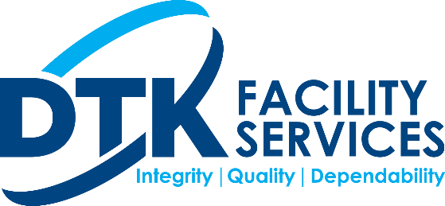

**Coronavirus Disease 2019 (COVID-19) / Memo to Employees**

**Purpose**

DTK Facility Services provides an integral role in infection prevention in the facilities we clean as well as a responsibility to ensure the safety and well being of our employees. Viruses, such as the coronavirus and the flu, present a challenge to our company and employees in providing a clean and safe facility for our employees and customers.

**Prevention**

* Wash your hands often with soap and water for at least 20 seconds. If soap and water are not available, use an alcohol-based hand sanitizer
* Avoid touching your eyes, nose, and mouth with unwashed hands
* Avoid close contact with people who are sick
* Stay home when you are sick
* Cover your cough or sneeze with a tissue, then throw the tissue in the trash
* Clean and disinfect frequently touched objects and surfaces.

**Safe Distancing Protocol for Employees**

* Do not report to work if you feel sick, especially the following:
  + You have a fever
  + You are experiencing upper respiratory illness type symptoms
  + You are coughing
  + You are experiencing shortness of breath
* Cough or sneeze into a tissue and then discard the tissue in the trash immediately. If you don’t have a tissue, sneeze or cough into your elbow.
* Practice safe distancing techniques, such as:
  + Maintain a distance of at least 6 feet from others
  + Do not shake hands or fist bump with others
  + Do not congregate in groups of 10 or more
  + Do not face others directly when talking with them, point you face at an angle to them so that you are not directly speaking
* Follow the Prevention steps outlined above